Exercise 1
In this assignment you will investigate HTTP, DNS and DHCP traffic using Wireshark. You will discover what information is added to the network packets and which underlying protocols are used by these application layer protocols.

Step 1: Get your computer information
The first step when examining network traffic or troubleshooting a problem is getting your own computer’s information. Try to find the following information and fill in the table at the end of this document.
- Connect your computer to the internet.
  - What is your IP address and subnet mask?
  - What is your default gateway?
  - What is your MAC address?
  - What is the IP address of your DNS server?
  - Which commands did you use to find this information?

Step 2: DHCP
Before your computer can communicate on the IP network, your computer needs an IP address. In the previous lab, you configured a static IP address. But this is not a convenient way to connect to a network because you need to know the which IP address you can use on that specific network, the subnetmask and all the other information needed to use the network and the internet. In most networks, a DHCP server is available that will automatically provide your computer with an IP address.
- Open Wireshark and start monitoring the network interface connected to the internet.
- Unplug your computer from the internet and plug it in again (or disconnect and reconnect your wifi network). Or you can get the same result by entering the following commands in a command prompt to request a new IP address from the DHCP server:
    - Ipconfig /release will delete your current ip address settings
    - Ipconfig /renew will ask for a new ip address
- Stop monitoring Wireshark
- In Wireshark, fill in the filter:
    - Dhcp
- Using the information available in Wireshark, fill in the table at the end of this document and try to answer these questions
  - The port numbers identify the applications to which the packet needs to be delivered. What is the port to which the DHCP servers application is listening?
  - What is the function of DHCP?
  - Which packets are send to and from the DHCP server in order to fulfill the function of DHCP?
  - Which protocol is used in the Transport layer (UDP or TCP)?
  - Is this a reliable or unreliable protocol?
  - Which protocol is used in the Network layer?
  - Can you find your IP address, subnet mask, MAC address and default gateway in the Wireshark capture?

Step 3: DNS
When surfing the web, humans use text based domain names to access webservers. However, computers in the IP network use IP addresses to find the desired destination. The DNS protocol is used to translate text based domain names to IP addresses.
- Open Wireshark and start monitoring your network traffic (Choose the network adapter connected to the internet).
- Open a web browser and visit the webpages http://httpforever.com/ and http://www.groenling.de/theend.html
- Stop monitoring with wireshark
- In Wireshark, fill in the filter:
    - dns
  - if you don’t see any lines in your Wireshark, it is possible that the ip addresses of these domains were already in your computer’s cache. To clear your computer’s DNS cache, open a command promt and enter the command “ipconfig /flushdns”. Restart monitoring and revisit both websites again.
- Using the information available in Wireshark, fill in the table at the end of this document and try to answer these questions
  - What is the IP address of the domain names?
    - You can verify this information by using the “nslookup” command in a command prompt.
  - Do the IP addresses you found in the DNS capture match the IP addresses you found using the nslookup command?
  - What is the IP address of the DNS server?
  - What is the port to which the DNS servers application is listening?
  - What is the function of DNS?
  - Which packets are send to and from the dns server in order to fulfill the function of DNS?
  - Which protocol is used in the Transport layer (UDP or TCP)?
  - Which protocol is used in the Network layer?

Step 4: HTTP
HTTP is the protocol used between webservers and webbrowsers to send the requested (requested by the clients) webpages from the webserver to the webbrowser. We use http websites because the content of the http packets is in plain text. Most webpages use the secure https protocol, which works mostly the same as http, with the big difference that the http packets are encrypted. Which means we would not be able to examine the https packets content.
- Work in the same capture as in “step 3: DNS” or repeat the process of opening the webpages in a new capture.
- In Wireshark you can filter packets on IP address. To find the IP address of both websites, you can:
    - Use the information you found in step 3
    - Use the “nslookup” command
  - What are the ip addresses of both sites?

- In Wireshark, fill in the following filter to view the packets transmitted to open the theendofinternet.com web page (change the IP address to the one you found for this server):
    - ip.addr==123.123.123.123 && http
- You should see several lines. Select the first HTTP GET line (the first line in most cases) and fill in the table at the end of this document.
- Select the first line HTTP 200 OK line (the second line in most cases) and fill in the table at the last page.
- Do this for both websites
- Using the information that you found, try to answer these questions
  - What is the port to which both websites listen, so which is the default destination port for webservers listening to the HTTP protocol?
  - What is significant about the destination MAC addresses of both HTTP GET requests? This is the MAC address of which device on the network?
  - Can you find the MAC address and IP address of your own computer in the table?
  - What kind of packets are send to and from the webserver in order to open a website?
  - Which protocol is used in the Transport layer (UDP or TCP)?
  - Which protocol is used in the Network layer?
Complete the network diagram at the bottom of the last page with the information that you found during this lab. It is possible that you can’t fill in all the information.

Computer Information
IP Address | Subnet Mask | Default Gateway | MAC Address | DNS servers

DHCP
Protocol name containing the information | ………………………… |  | ………………………… |  | ………………………… |  | …………………………
 | Source  MAC | Dest.  MAC | Source  IP | Dest.  IP | Source  Port | Dest.  Port | Offered IP address, subnet mask, dns server, …
DHCP Discover
DHCP Offer
DHCP Request
DHCP ACK

DNS
Protocol name containing the information | ………………………… |  | ………………………… |  | ………………………… |  | …………………………
 | Source  MAC | Dest.  MAC | Source  IP | Dest.  IP | Source  Port | Dest.  Port | The ip address of the domain name
DNS – Standard query
theendofinternet.com
DNS – Standard query response
theendofinternet.com
DNS – Standard query
www.groenling.de/theend.html
DNS – Standard query response
www.groenling.de/theend.html

HTTP
Protocol name containing the information | ………………………… |  | ………………………… |  | ………………………… |  | …………………………
 | Source  MAC | Dest.  MAC | Source  IP | Dest.  IP | Source  Port | Dest.  Port | Content of the packet (GET or Line-based text data within HTTP protocol line)
HTTP – GET
theendofinternet.com
HTTP – 200 OK
theendofinternet.com
HTTP – GET
www.groenling.de/theend.html
HTTP – 200 OK
www.groenling.de/theend.html

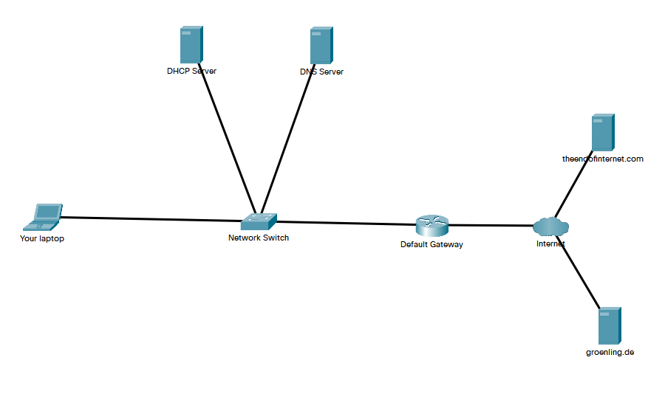
Ip address:
Mac address:
Port webserver:
Ip address:
Mac address:
DNS server application port:
Ip address:
Mac address:
DHCP server application port:
Ip address:
Mac address:
Ip address:
Mac address:
Ip address:
Mac address:
Port webserver:

Local network

